Goals and audience



Wish List

Status In progress

Timing Date to Date

# GOALS

* Private Human-AI Math Lab for Adam
* Film Studio for Hala
* Botanical Garden for Gnochi
* Private Airport for Pope
* Biryani Restaurant for me
* Alexandria Museum, Australia The Library That Listens (+body?)

# AUDIENCE PERSONA

Breakdown the audience persona and add as much detail as possible for each. This might include: age, gender, income, education, interests, preferences, pain points, and more. These are examples and not a complete list of attributes.

| Persona | Priority | Demographics | Interests | Preferences | Pain points |
| --- | --- | --- | --- | --- | --- |
| City strivers | Primary | 25-35 years old  Urban centers  70% college degree  38% earn $55,000-$75,000 | Dining out  Entertainment  Travel  Fitness and wellness | On-demand services  Socially conscious brands  Unique experiences | High city costs  Work-life balance  Student loans |
| Student | Secondary | 18-25 years old  Urban centers | School activities  Activism | On-demand services  Socially conscious brands | Cost of living  School/life balance |
| Small business owners | Tertiary | 30-60 years old  Small town to urban centers | Dining out  Sports entertainment | On-demand services | Business investment  Economic trends |

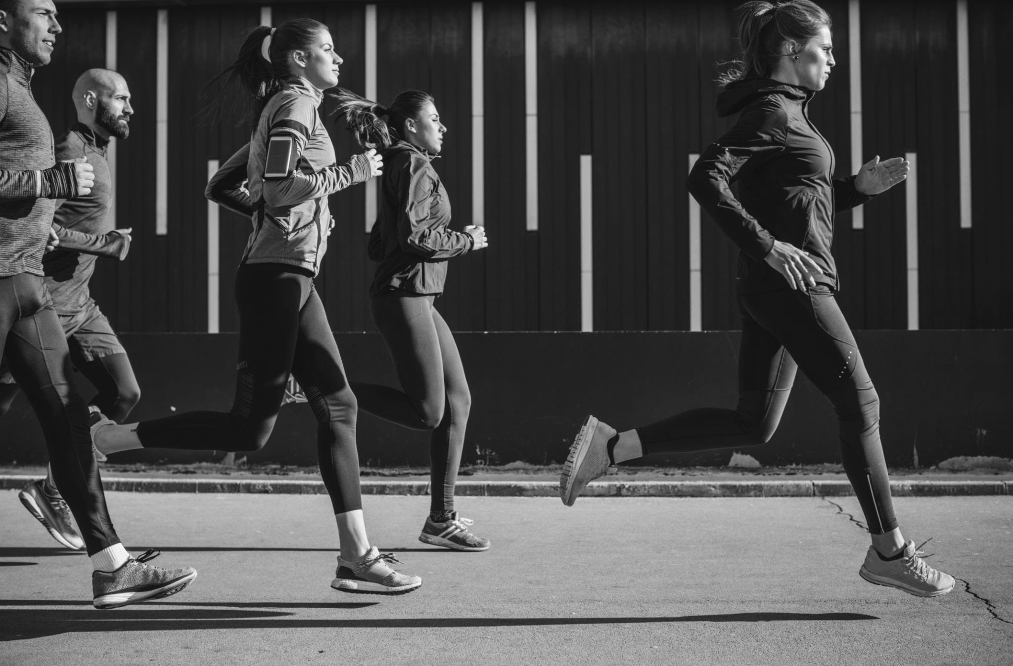

Content schedule



CONTENT SCHEDULE

| Release date | Title | Type | Description | Platform | Creator | Deadline | Status |
| --- | --- | --- | --- | --- | --- | --- | --- |
| Date | Product demo | Video | An entertaining 30 second video that introduces the product in a fun and engaging way | YouTube | Person | Date | Completed |
| Date | Content 2 | Social post | Add description | Add platform | Person | Date | In progress |
| Date | Content 3 | Podcast/Audio | Add description | Add platform | Person | Date | In progress |
| Date | Content 4 | Email | Add description | Add platform | Person | Date | In progress |
| Date | Content 5 | Article | Add description | Add platform | Person | Date | Blocked |
| Date | Content 6 | Webinar | Add description | Add platform | Person | Date | In progress |

Example 1: product demo details



PRODUCT DEMO DETAILS

| **Type:** | Video |
| --- | --- |
| **Platform:** | YouTube |
| **Link:** | File |



# CONTENT EVALUATION

| **Shares, likes, or comments** | 750/3,800/240 |
| --- | --- |
| **Follower growth** | 625 |
| **Social engagement rate** | 4.2% |
| **Click-through rate** | 1.8% |
| **Lead generation rate** | 12% |
| **Conversion rate** | 6% |
| **Notes** | Strong performance |

# SELECTED QUOTES

| Quote link | Quote link | Quote link |
| --- | --- | --- |

Content 2



CONTENT 2

| **Type:** | Social post |
| --- | --- |
| **Platform:** | Platform name |
| **Link:** | File |

# CONTENT EVALUATION

*Track the content’s performance. This could be quantitative data such as likes and comments, or qualitative data such as comment sentiment.*

| **Shares, likes, or comments** | # or NA |
| --- | --- |
| **Follower growth** | # or NA |
| **Social engagement rate** | # or NA |
| **Click-through rate** | # or NA |
| **Lead generation rate** | # or NA |
| **Conversion rate** | # or NA |
| **Notes** | Notes or NA |

# SELECTED QUOTES

Link to noteworthy quotes.

| Quote link | Quote link | Quote link |
| --- | --- | --- |

Content 3



CONTENT 3

| **Type:** | Podcast/Audio |
| --- | --- |
| **Platform:** | Platform name |
| **Link:** | File |

# CONTENT EVALUATION

*Track the content’s performance. This could be quantitative data such as likes and comments, or qualitative data such as comment sentiment.*

| **Shares, likes, or comments** | # or NA |
| --- | --- |
| **Follower growth** | # or NA |
| **Social engagement rate** | # or NA |
| **Click-through rate** | # or NA |
| **Lead generation rate** | # or NA |
| **Conversion rate** | # or NA |
| **Notes** | Notes or NA |

# SELECTED QUOTES

Link to noteworthy quotes.

| Quote link | Quote link | Quote link |
| --- | --- | --- |

Content 4



CONTENT 4

| **Type:** | Email |
| --- | --- |
| **Platform:** | Platform name |
| **Link:** | File |

# CONTENT EVALUATION

*Track the content’s performance. This could be quantitative data such as likes and comments, or qualitative data such as comment sentiment.*

| **Shares, likes, or comments** | # or NA |
| --- | --- |
| **Follower growth** | # or NA |
| **Social engagement rate** | # or NA |
| **Click-through rate** | # or NA |
| **Lead generation rate** | # or NA |
| **Conversion rate** | # or NA |
| **Notes** | Notes or NA |

# SELECTED QUOTES

Link to noteworthy quotes.

| Quote link | Quote link | Quote link |
| --- | --- | --- |

Content 5



CONTENT 5

| **Type:** | Article |
| --- | --- |
| **Platform:** | Platform name |
| **Link:** | File |

# CONTENT EVALUATION

*Track the content’s performance. This could be quantitative data such as likes and comments, or qualitative data such as comment sentiment.*

| **Shares, likes, or comments** | # or NA |
| --- | --- |
| **Follower growth** | # or NA |
| **Social engagement rate** | # or NA |
| **Click-through rate** | # or NA |
| **Lead generation rate** | # or NA |
| **Conversion rate** | # or NA |
| **Notes** | Notes or NA |

# SELECTED QUOTES

Link to noteworthy quotes.

| Quote link | Quote link | Quote link |
| --- | --- | --- |

Content 6



CONTENT 6

| **Type:** | Webinar |
| --- | --- |
| **Platform:** | Platform name |
| **Link:** | File |

# CONTENT EVALUATION

*Track the content’s performance. This could be quantitative data such as likes and comments, or qualitative data such as comment sentiment.*

| **Shares, likes, or comments** | # or NA |
| --- | --- |
| **Follower growth** | # or NA |
| **Social engagement rate** | # or NA |
| **Click-through rate** | # or NA |
| **Lead generation rate** | # or NA |
| **Conversion rate** | # or NA |
| **Notes** | Notes or NA |

# SELECTED QUOTES

Link to noteworthy quotes.

| Quote link | Quote link | Quote link |
| --- | --- | --- |